**Sierra Clayton**

CIS 241 - Web Dev 1 Final Project

9th December 2020

**OVERVIEW**

**Contents**

This site contains 5 pages with links to each, included on every page. There are some graphics and a form on the guestbook page.

**Features**

This is a very basic site with little to no features.

**Pages**

Home Page – The home page will give an overview/introduction

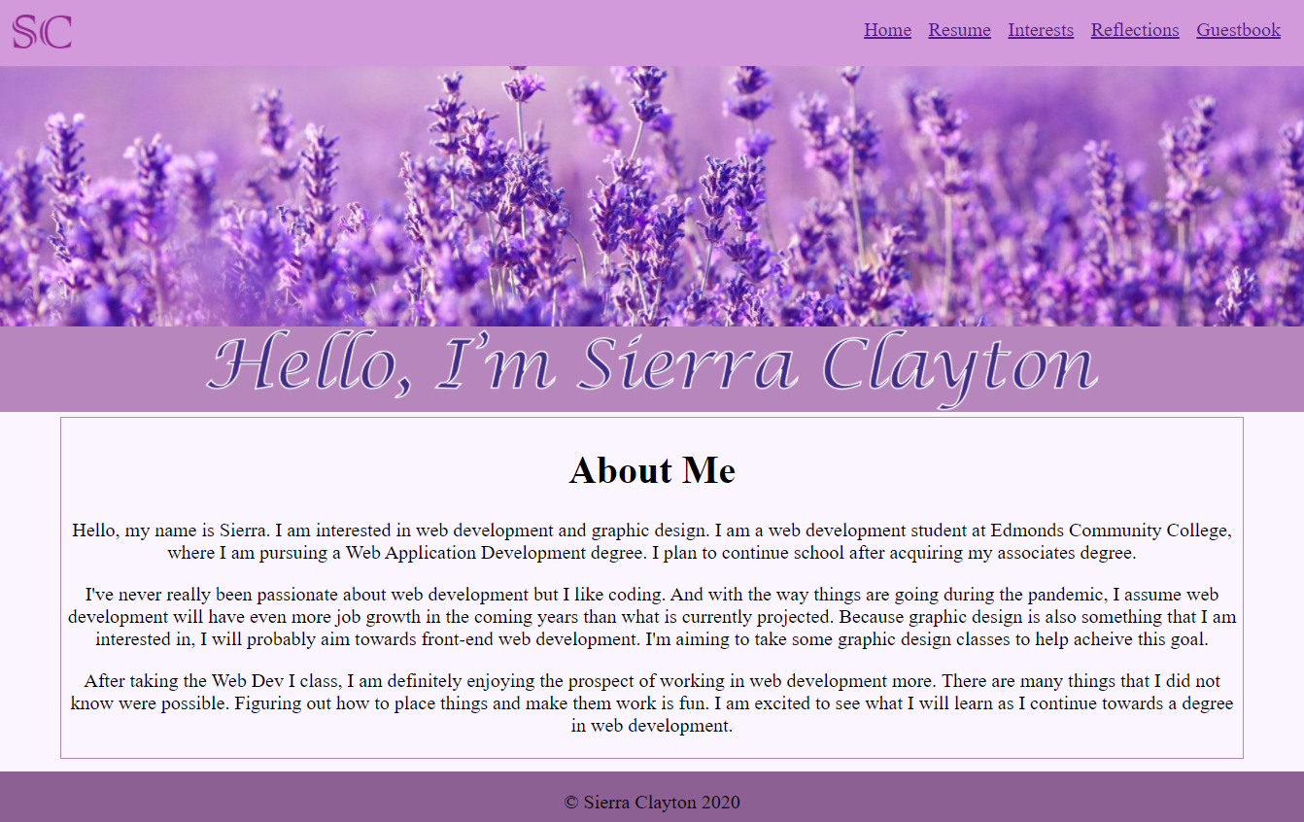

Resume Page – Provides information on education and work experience

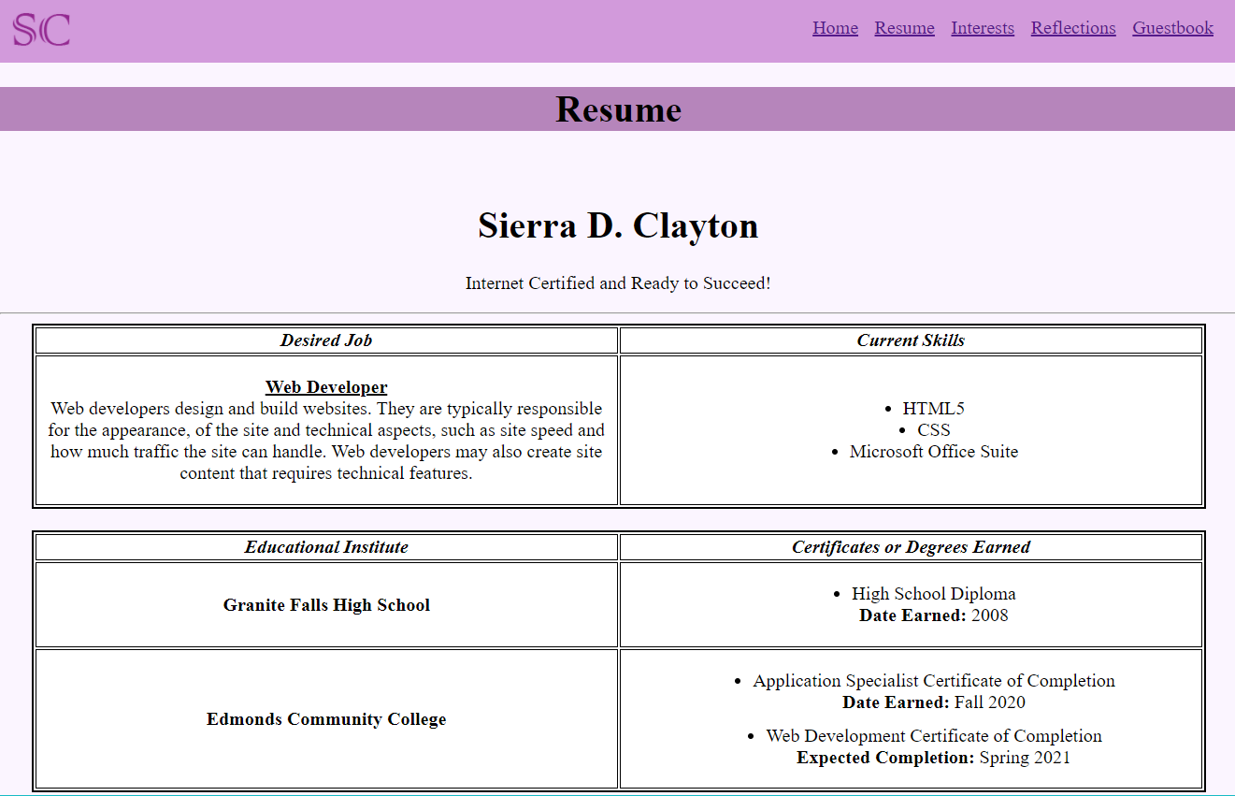

Interests Page – A quick overview of personal interests

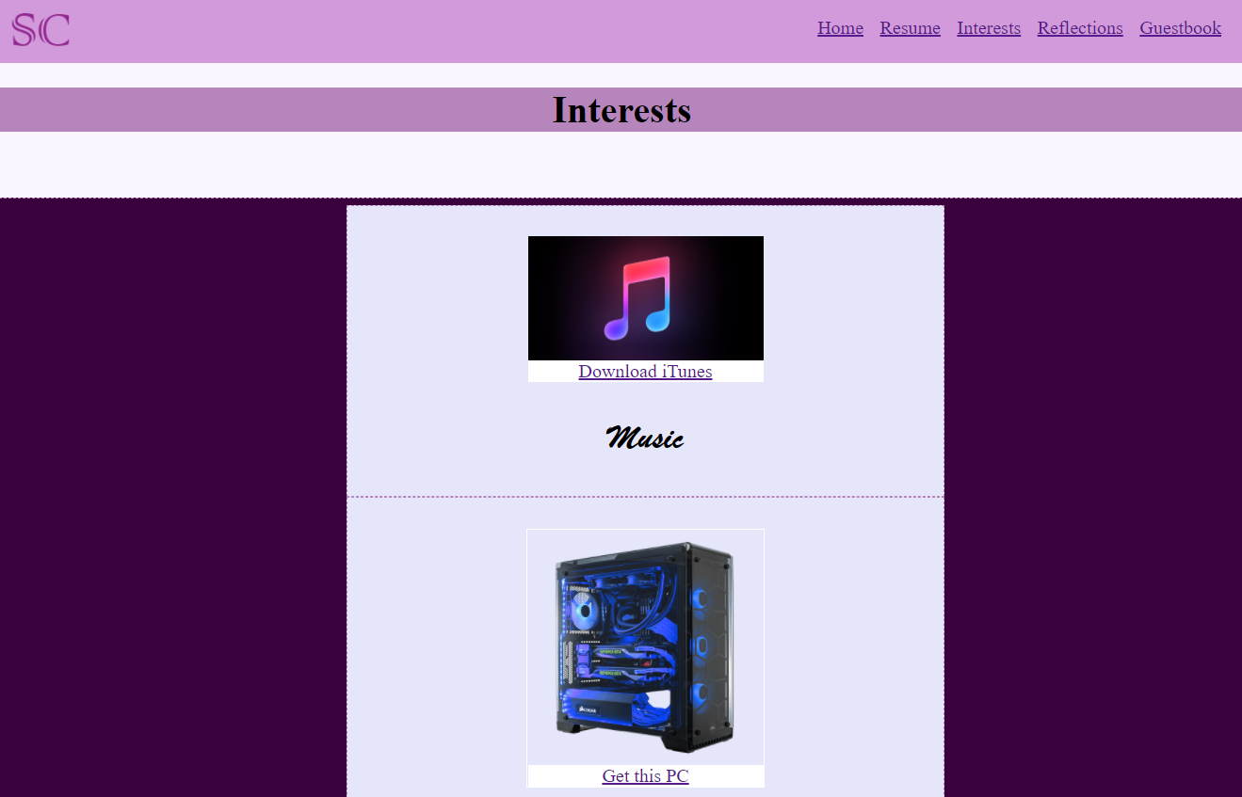

Reflections Page – A short reflection on the Web Dev 1 class

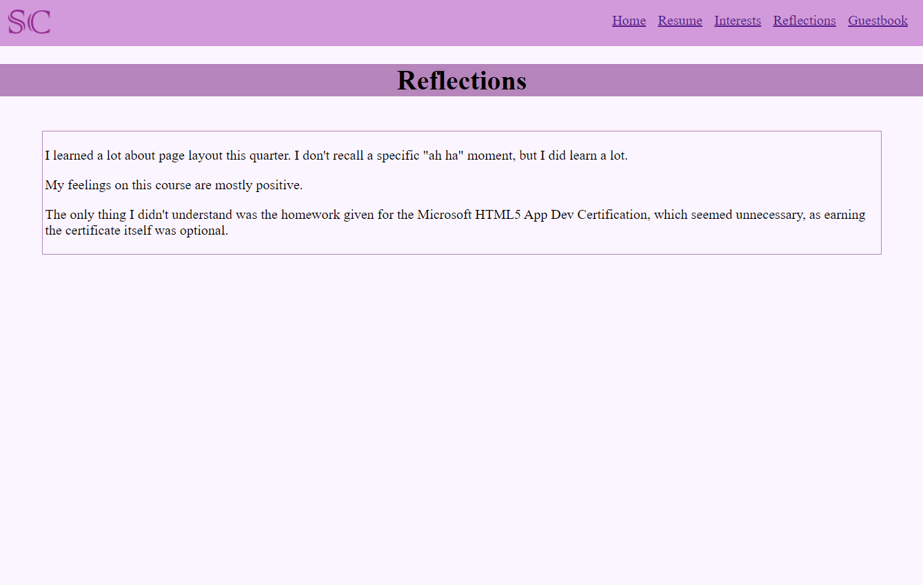

Guestbook Page – A page for visitors to enter their name, website (if they have one), and comments

